**Advance Application Programming in Python**

**Project Documentation**

**Project Title - Resume Builder**

**Project Team Members**

Sindhu Pallapothu - 700759820

Vedasrujana Katta - 700758962

Venkata Vamsi Krishna Kalisetty - 700758961

Sanjanadevi Alla- 700759099

**Abstract**

* Resume Bulider is an online application that creates professional resumes.
* It provides a straightforward and easy way for users to enter their name, personal information, professional work experience, educational background, skills, and other pertinent data.
* This data is utilised to create a formatted resume in multiple styles. We may choose the most appropriate format and style and download it to your desktop.

**Introduction**

• A strong Resume is necessary in today's cutthroat job market in order for applicants to properly highlight their qualifications and land a job.   
•We have created a resume builder programme to tackle these issues, streamlining the resume-creation process and making it effective and user-friendly for users of all skill levels.   
• This resume builder creates a solid and user-friendly platform by utilising contemporary web technologies.   
• Python Flask, a web framework that simplifies the development of web applications, is used to construct the backend.   
• Key functions including data processing, user authentication, and database communication are handled by Flask.   
• The programme employs a SQLITE database to store data, guaranteeing that user data is easily accessed and securely kept.

**Technologies Used**

* Python - Backend
* Flask - Framework
* SQLITE - Database
* HTML – Frontend
* CSS - Styling
* JavaScript – To make Web Application Dynamic

**For Running the Program**

1. To Run the program first we need to move to the directory using cd command in terminal

cd downloads/resume-builder-main

1. To install all the requirements run the following command

python -m pip install -r requirements.txt

1. To run the web application we need to run the flask using following command

flask --app index:app run

**Implementation Steps**

1. Register to the Application
2. Login to web application
3. Enter details in each field required in the home page
4. Select the template and fonts
5. Preview the resume
6. Download the resume

**Output Screenshots**

1.Register

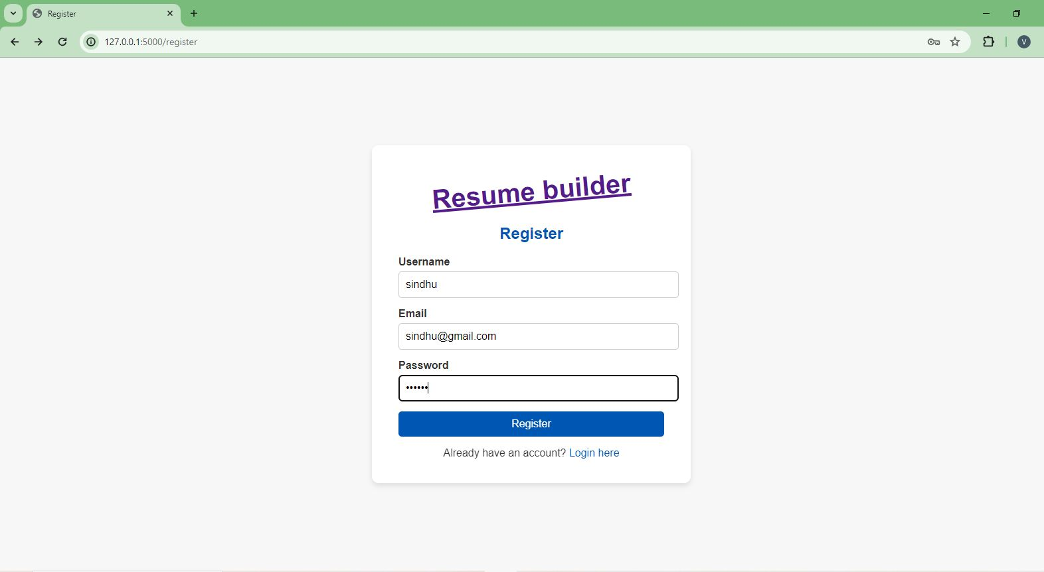2. Login to the user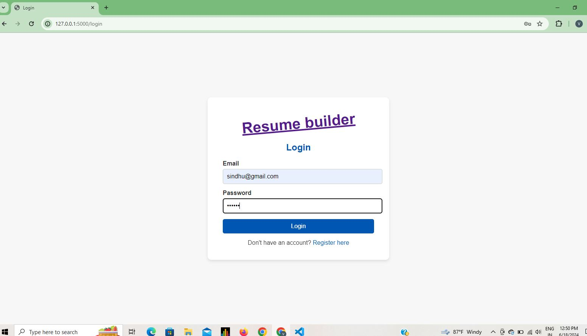

3. Enter details in each field required in the home page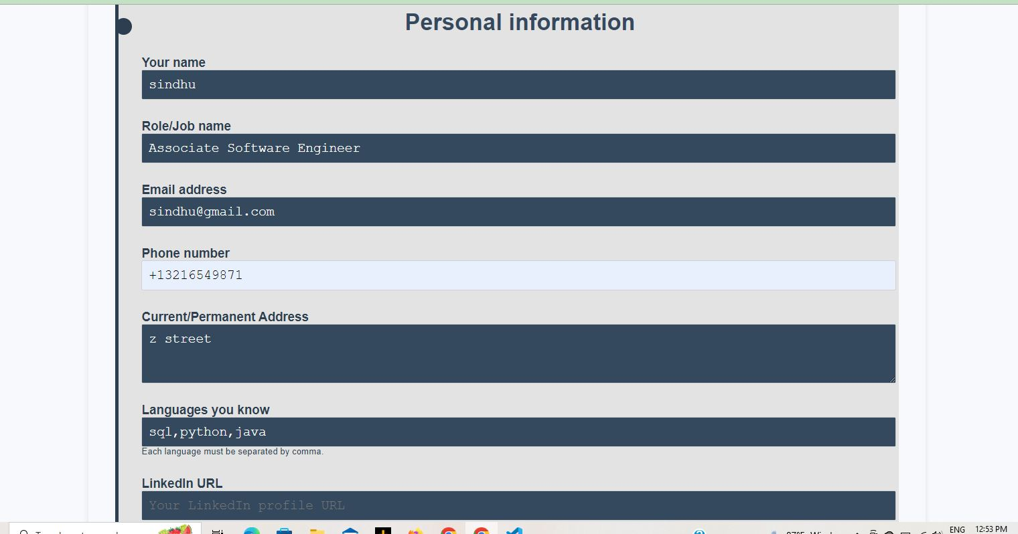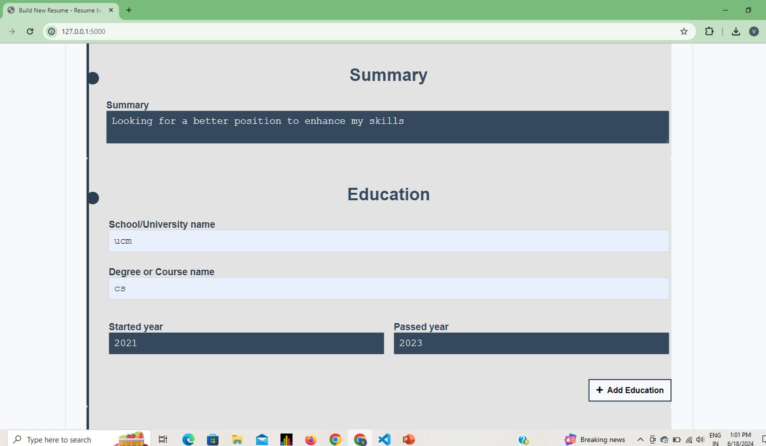

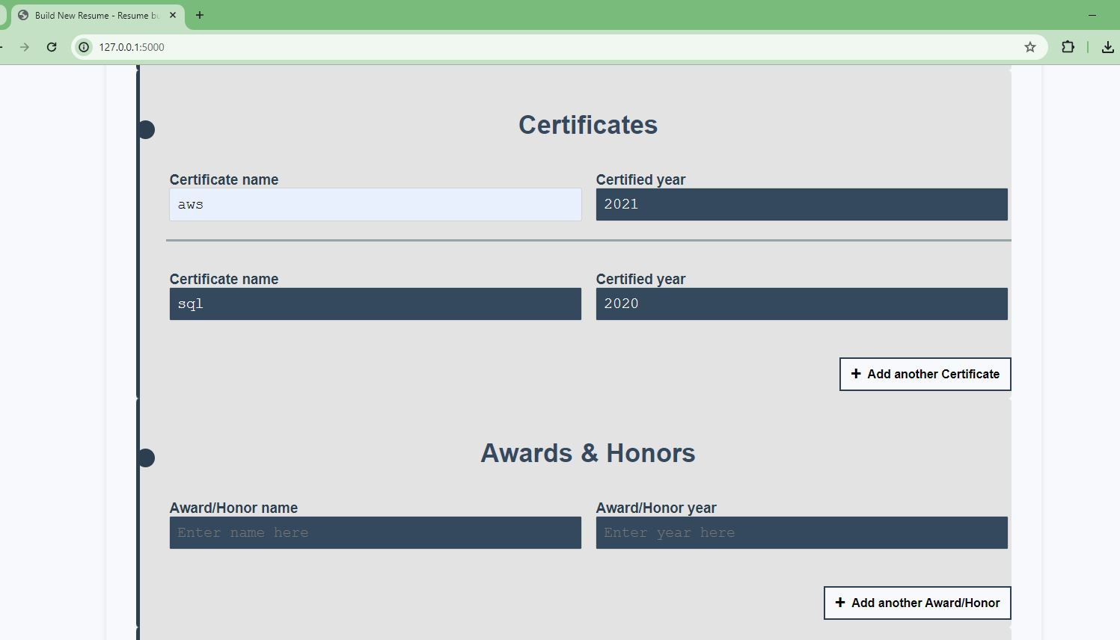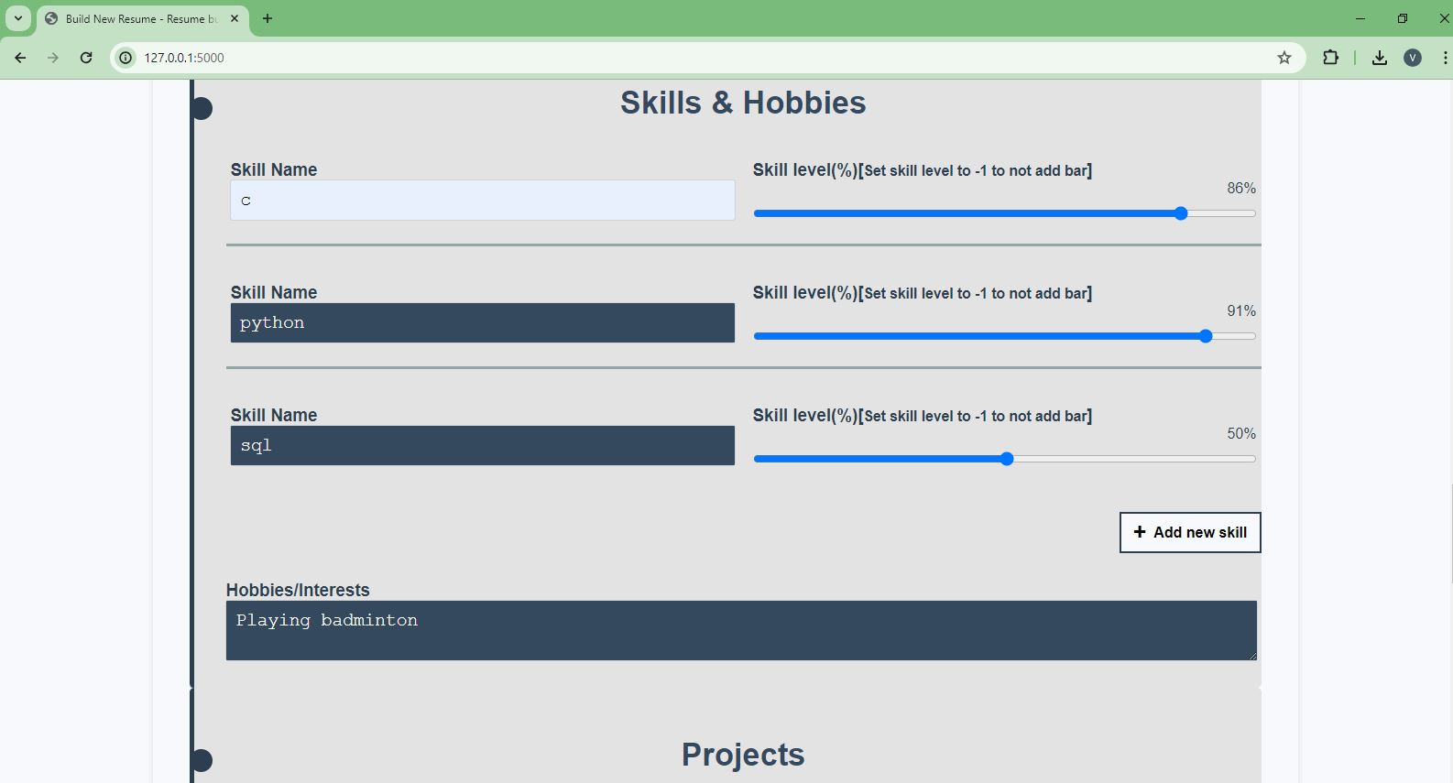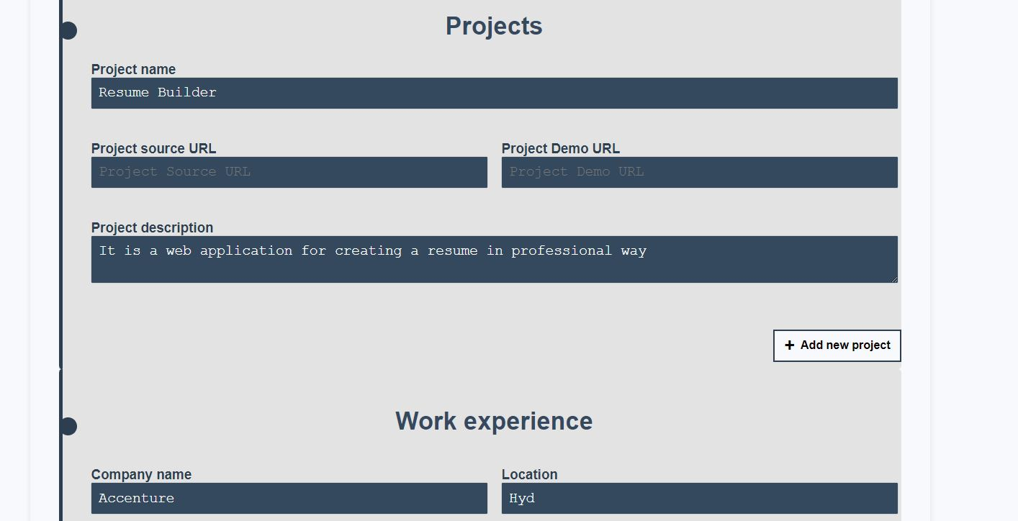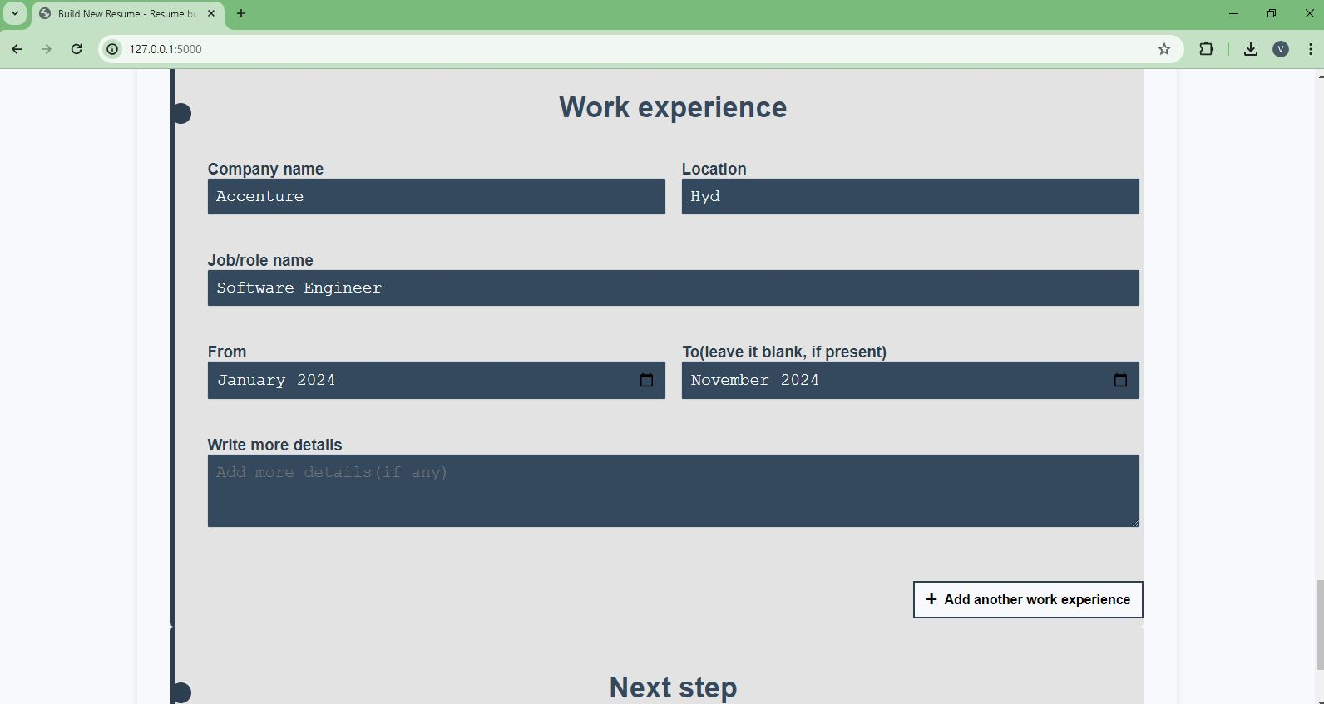

4. Select template and font

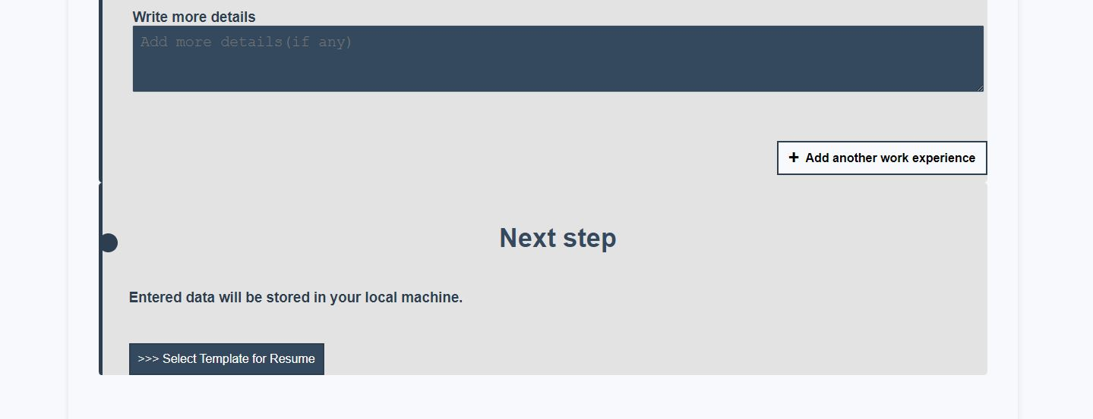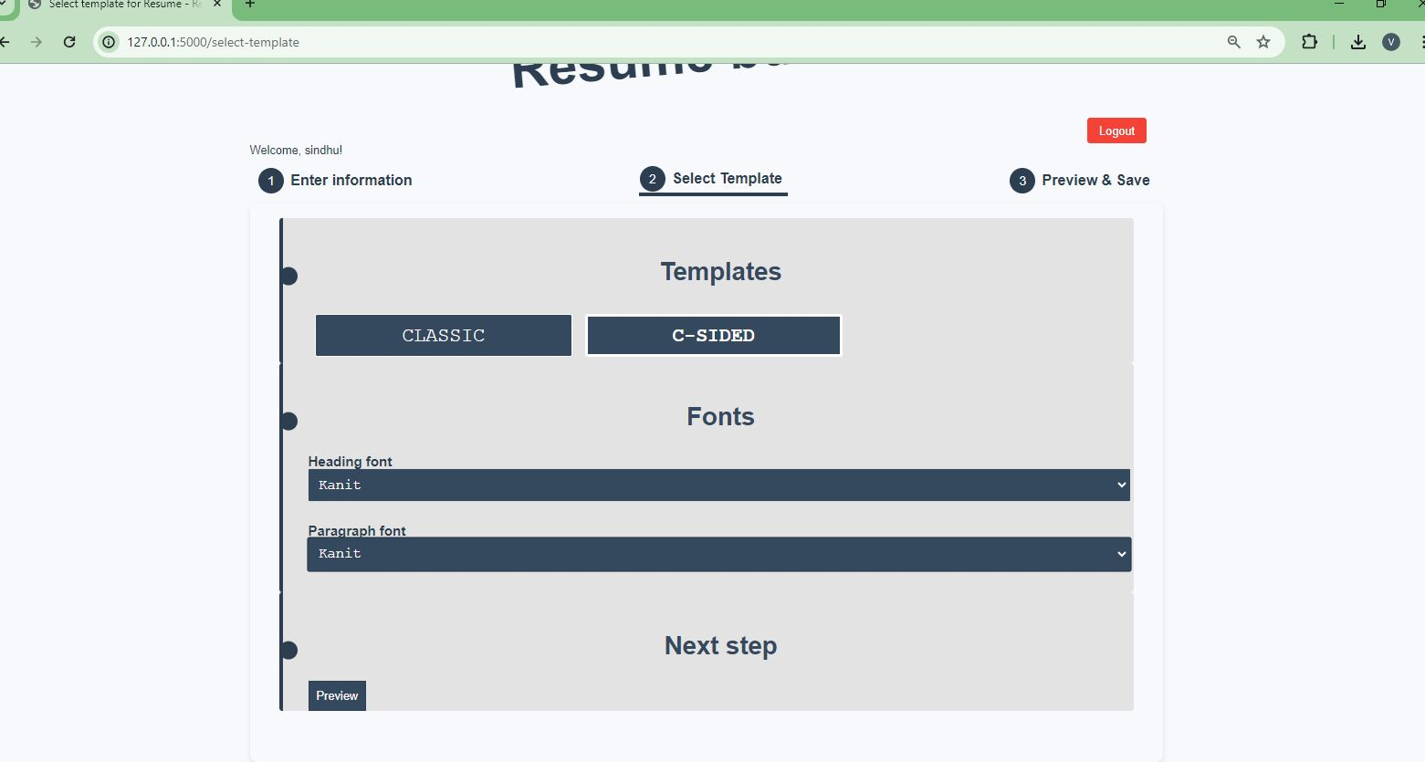

5. Preview the Resume

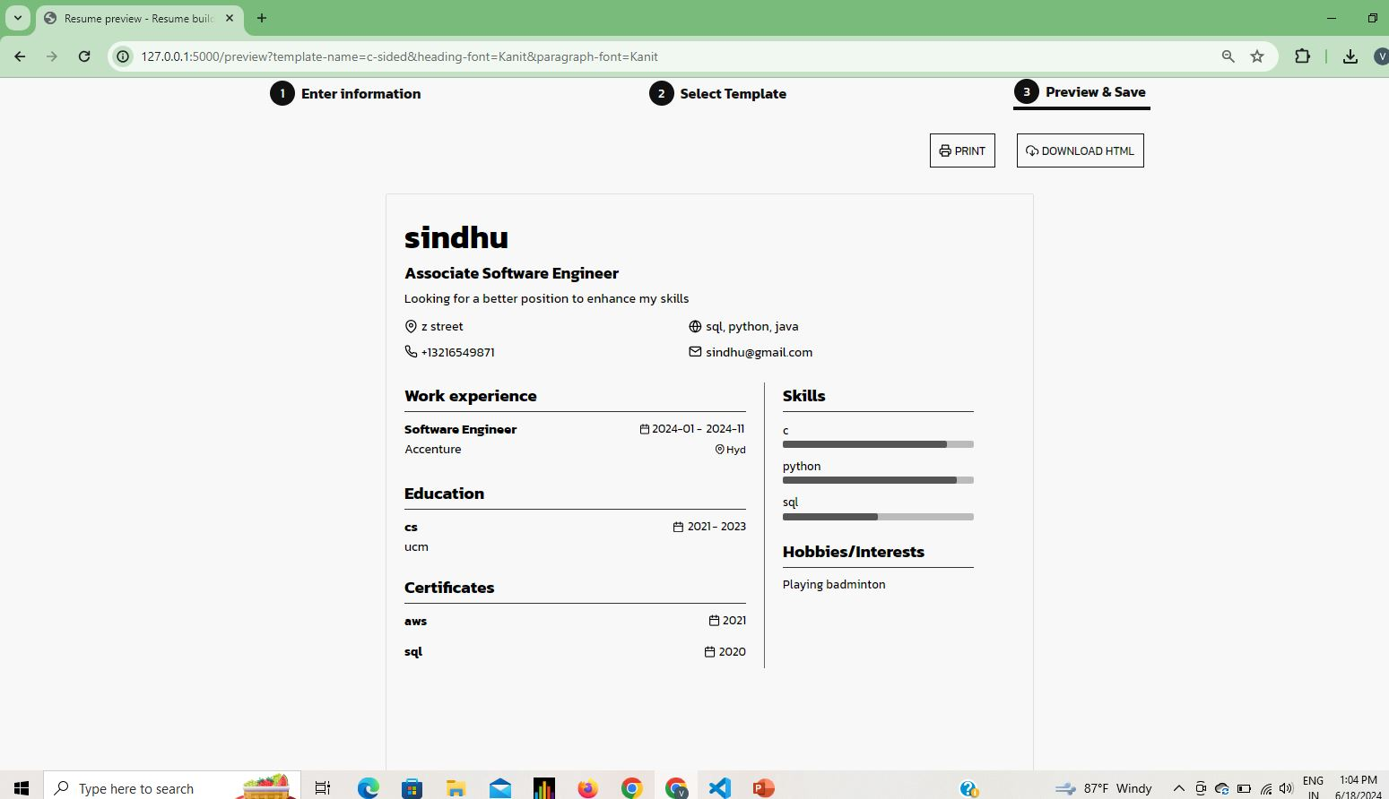

1. Download the Resume



**Conclusion**

Using python and flask framework we have developed a web application for developing a resume just by taking required inputs from the user for a Professional Resume.